Farm Constructed Wetlands for Nutrient Removal and Recovery from Agricultural Drainage Water
S. Lavrnić¹*, G. Mancuso¹, F. Chioggia¹, S. Anconelli², A. Toscano¹
¹Alma Mater Studiorum - University of Bologna, Department of Agricultural and Food Sciences, Section of Agricultural Engineering, Viale Fanin 50, 40127 Bologna, Italy. E-mail: stevo.lavrnic@unibo.it
²Consorzio di Bonifica Canale Emiliano Romagnolo, via E. Masi 8, 40137 Bologna, Italy

Keywords. Constructed wetland, Agricultural drainage water, Nutrient recovery
Abstract. Agricultural areas are one of the most important non-point sources of pollution, which can cause negative effects in different types of ecosystems. Drainage water from these areas often contains considerable concentrations of nutrients and pesticides, pollutants that are important to be intercepted. Moreover, nutrients present in agricultural drainage water, if reused, could be an important resource in the agricultural production.
Constructed wetlands (CWs) are a nature-based technology that can be used for treatment of different types of polluted waters. Their advantage lies in the fact that they can manage variable water flows and pollutant loads, common of agricultural drainage water.
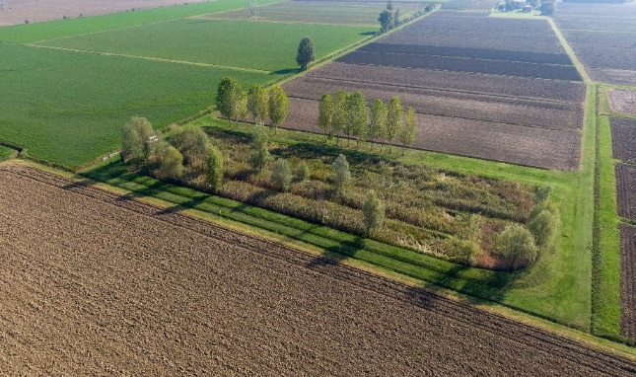
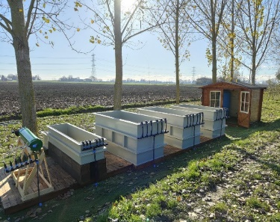
To assess these aspects, a full-scale surface flow CW (SFCW), located in Metropolitan City of Bologna, was monitored taking into account its inflows and outflows. The field site is a 12.5 ha experimental farm operated by Land Reclamation Consortium Canale Emiliano Romagnolo. At the same site, a pilot plant was built in order to test effect of different CW types and substrates such as biochar on the nutrient recovery (Figure 1).
Figure 1 - The full-scale SFCW and the pilot plant at the experimental farm
The experimental part, done within the H2020 project WATERAGRI, aimed to evaluate a possibility for nutrient recovery through uptake of plants and adsorption on the substrate. The first results have shown that plants can accumulate important part of the influent nutrient load and therefore a further processing of these materials could yield soil amendments, contributing to the overall circularity of agricultural production.

